**Registration no: 12203364**

**Name: kushvanth chapala**

**Docker on EC2 (Ubuntu) – Build & Push to Amazon ECR**

**Step 1:** Launch Ubuntu EC2 Instance and Connect

1. Go to AWS Console → EC2 → Launch Instance.
2. Choose Ubuntu (e.g., Ubuntu 22.04 LTS).
3. Select instance type (e.g., t2.micro).
4. In "Configure Instance", attach an IAM role with this policy:
   * AmazonEC2ContainerRegistryFullAccess
5. Add a security group allowing SSH (port 22).
6. Launch the instance.

Go to EC2 dashboard → Select your instance → Click Connect → Choose EC2 Instance Connect → Click Connect.

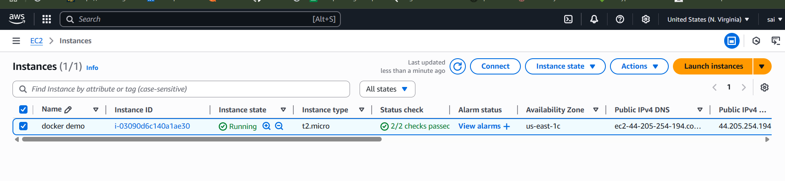

**Step 2: Install Docker on the EC2 Ubuntu Instance**

📍 **Run these commands in the EC2 terminal (connected via EC2 Instance Connect):**

# Update the package list

sudo apt update -y

# Install Docker

sudo apt install -y docker.io

Stuck here….

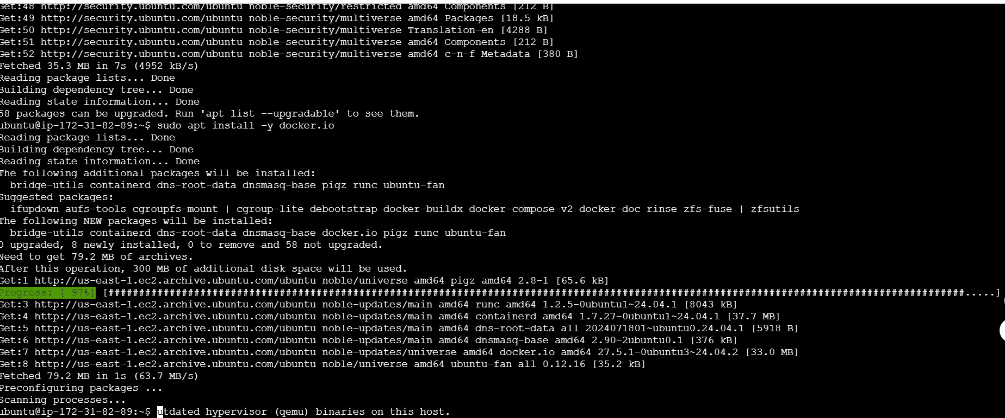

Refresh the page, then proceed with the next commands…

# Start the Docker service

sudo systemctl start docker

# Enable Docker to start on system reboot

sudo systemctl enable docker

# Add the current user (ubuntu) to the docker group

sudo usermod -aG docker ubuntu

🔁 **Important:** Log out and reconnect to your instance to apply the group change. Or run:

newgrp docker

# Check docker version

docker –version

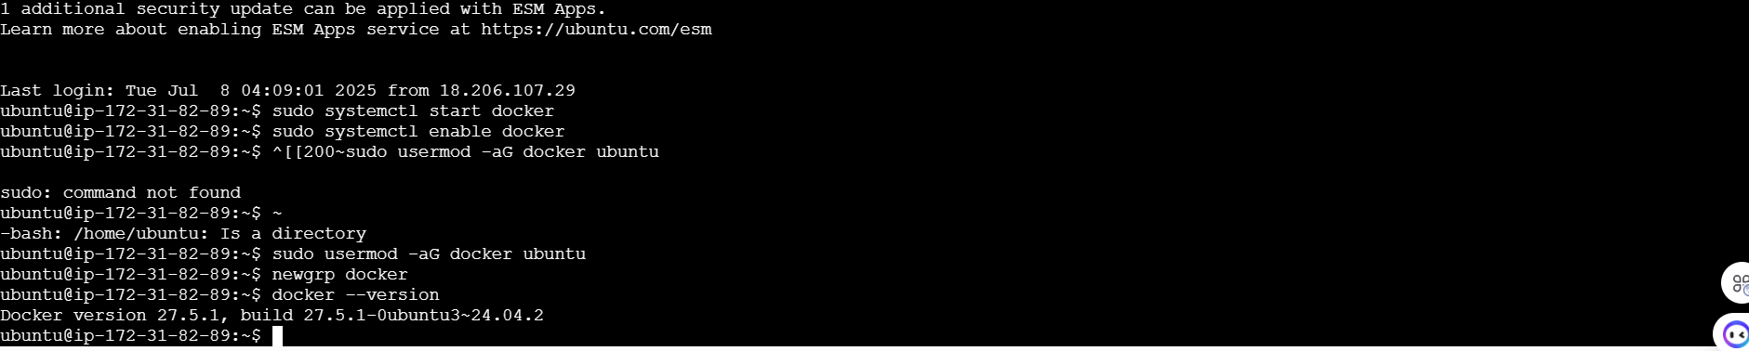

**✅ Step 3: Create Sample Python App & Dockerfile**

📍 **Still on the EC2 instance terminal:**

# Create a project directory

mkdir demo-app && cd demo-app

# Create a simple Python script

echo 'print("Hello from Docker on Ubuntu EC2!")' > app.py

# Create a Dockerfile

nano Dockerfile

**Paste the following into the Dockerfile:**

FROM python:3.9-slim

COPY app.py / app.py

CMD ["python", "/app.py"]

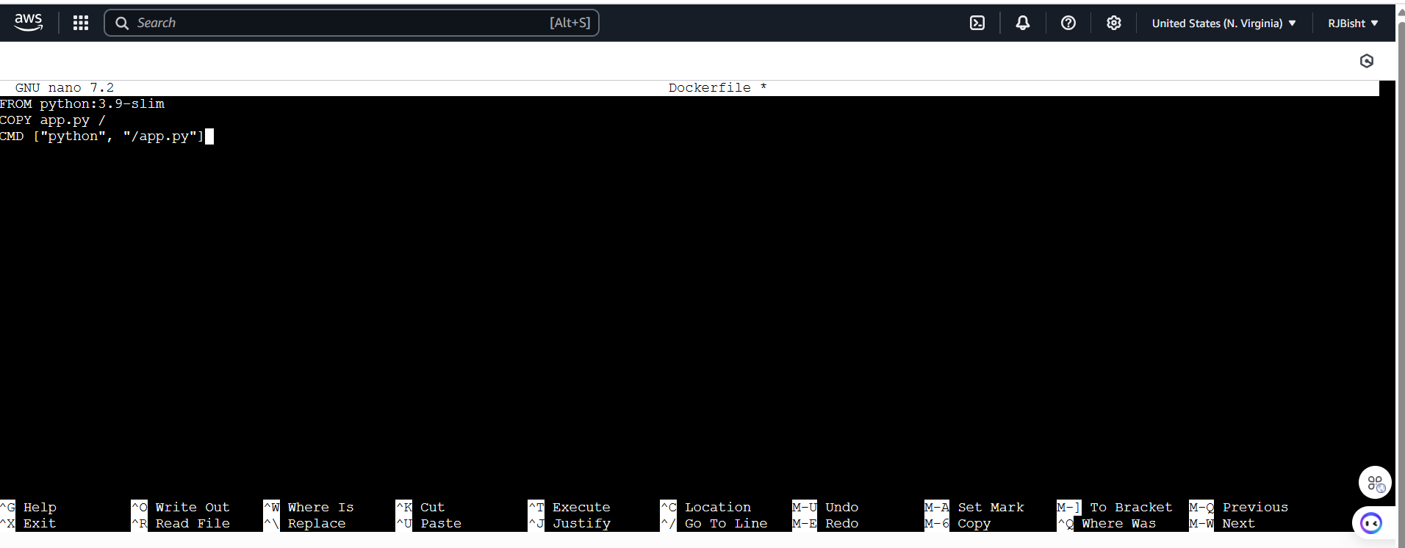

**After this Save using: CTRL+O, then ENTER, then CTRL+X**

**Then you come here…**

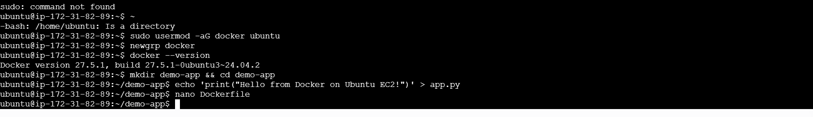

**✅ Step 4: Build Docker Image**

# 📍 Run in your demo-app directory:

docker build -t demo-app .

📦 This builds the image with the tag demo-app.

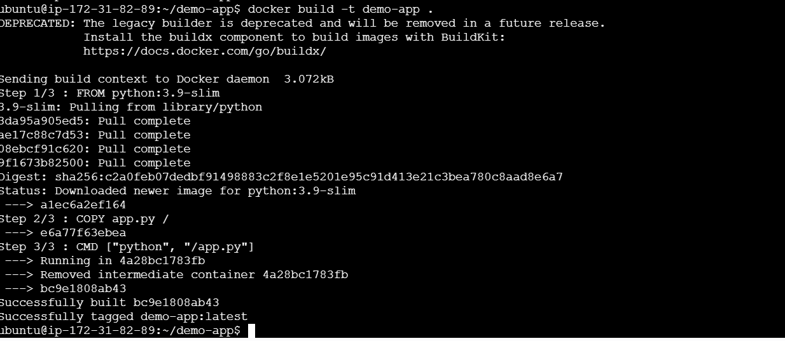

✅ **Step 5: Create Amazon ECR Repository**

# Now check whether AWS CLI is installed or not by checking

aws –version

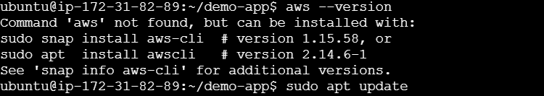

If AWS CLI is **not installed**, follow this first:

sudo apt update

sudo apt install unzip curl -y

curl "https://awscli.amazonaws.com/awscli-exe-linux-x86_64.zip" -o "awscliv2.zip"

unzip awscliv2.zip

sudo ./aws/install

aws –version

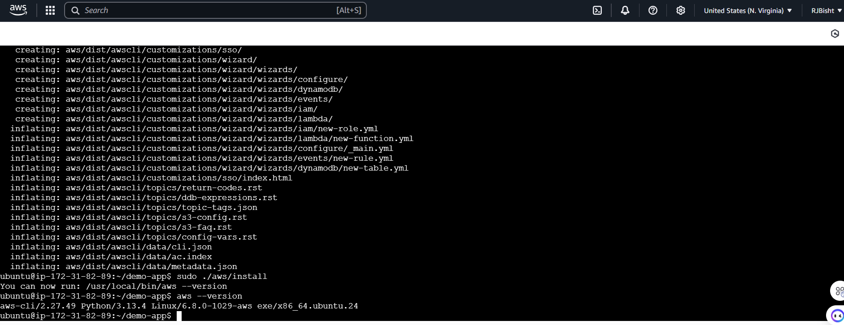

After this go for

aws configure

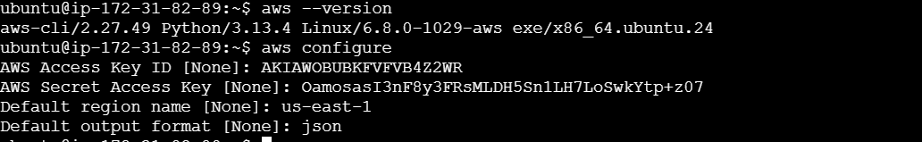

Now, create the repository:

aws ecr create-repository --repository-name demo-app

If this error comes:



Then go to IAM user add permission to that:

AmazonEC2ContainerRegistryFullAccess

Now, create the repository:

aws ecr create-repository --repository-name demo-app

🔑 **Copy the repositoryUri** from the output (e.g.):

“442490769770.dkr.ecr.us-east-1.amazonaws.com/demo-app”

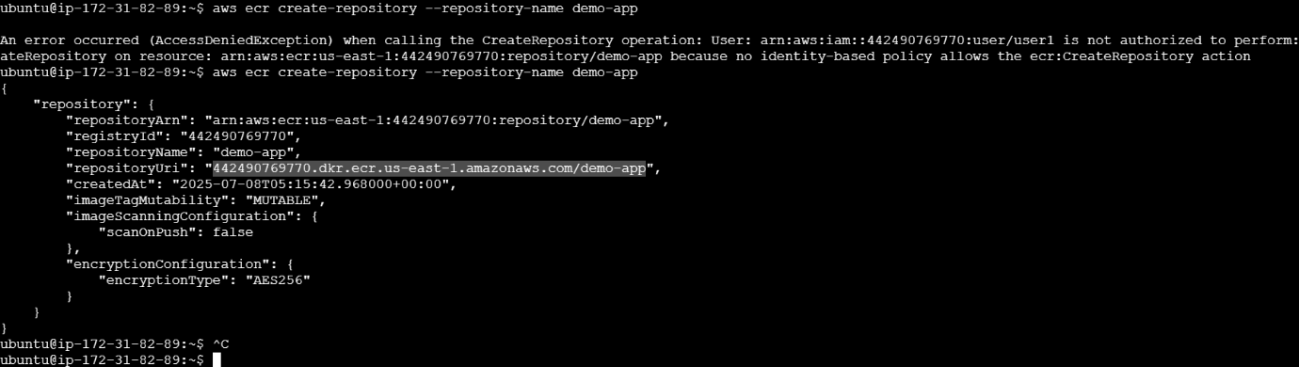

As you see my uri as mentioned above:

**✅ Step 6: Authenticate Docker to ECR**

aws ecr get-login-password | docker login --username AWS --password-stdin 123456789012.dkr.ecr.us-east-1.amazonaws.com

✅ This logs Docker into your ECR repo.

In above code change acc to your uri and new, correct command will be:

aws ecr get-login-password | docker login --username AWS --password-stdin 442490769770.dkr.ecr.us-east-1.amazonaws.com

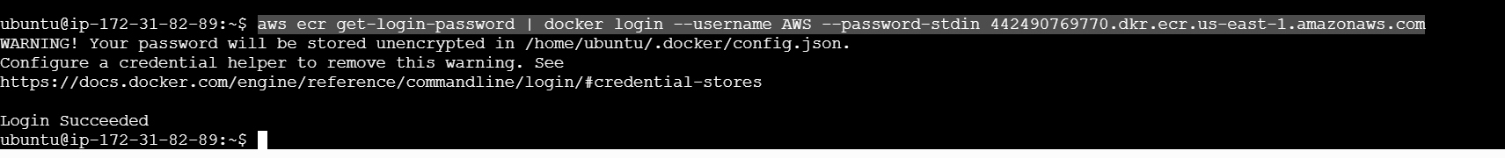

**✅ Step 7: Tag Docker Image for ECR**

docker tag demo-app:latest 123456789012.dkr.ecr.us-east-1.amazonaws.com/demo-app:latest

📌 Replace 123456789012 and us-east-1 with your **account ID** and **region**.

And new command will be :

docker tag demo-app:latest 442490769770.dkr.ecr.us-east-1.amazonaws.com/demo-app:latest

**✅ Step 8: Push Docker Image to ECR**

docker push 442490769770.dkr.ecr.us-east-1.amazonaws.com/demo-app:latest

📤 This uploads your image to Amazon ECR.

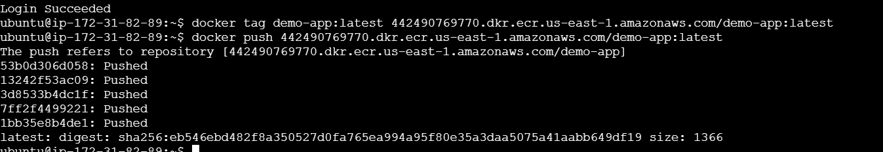

**✅ Step 9: Run Docker Container on EC2**

docker run demo-app

📥 Output:

Hello from Docker on Ubuntu EC2!

